1. Data model

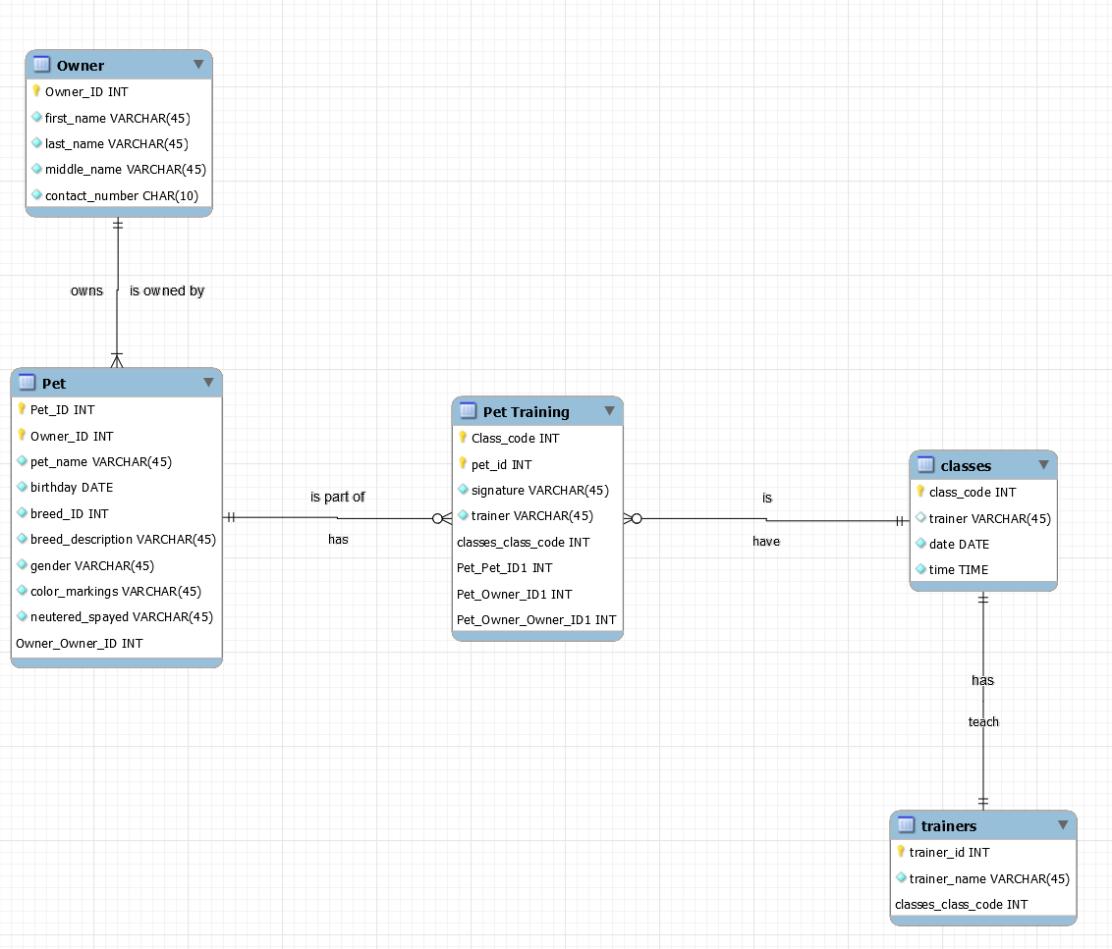

2. Describe statements

DESCRIBE owner:

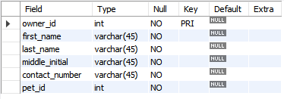

DESCRIBE pet:

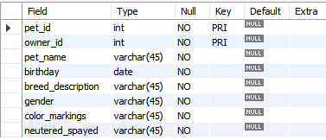

DESCRIBE classes:

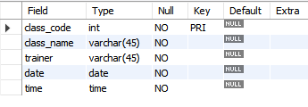

DESCRIBE trainers:

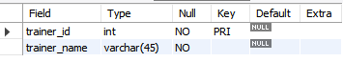

DESCRIBE pet_training:

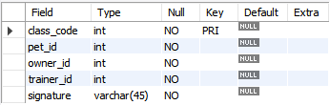

3. Inserts and queries

**SQL Statements**:

1. Owner

INSERT INTO owner (owner_id, first_name, last_name, middle_initial, contact_number, pet_id)

VALUES (1, "Michael", "Stowell", "D", "720-838-0249", 1);

INSERT INTO owner (owner_id, first_name, last_name, middle_initial, contact_number, pet_id)

VALUES (2, "Dannie", "Pothier", "P", "720-112-1242", 2);

INSERT INTO owner (owner_id, first_name, last_name, middle_initial, contact_number, pet_id)

VALUES (3, "Susan", "Anthony", "B", "720-345-6830", 3);

INSERT INTO owner (owner_id, first_name, last_name, middle_initial, contact_number, pet_id)

VALUES (4, "Tyler", "Stowell", "M", "720-476-6924", 4);

Query:

SELECT owner_id, first_name, last_name, middle_initial, contact_number, pet_id

FROM owner

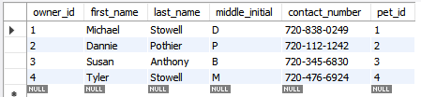

2. Pet

INSERT INTO pet (pet_id, owner_id, pet_name, birthday, breed_description, gender, color_markings, neutered_spayed)

VALUES (1, 1, "Buster", 20180306, "Rotwiler", "Male", "Brown/Black", "yes");

INSERT INTO pet (pet_id, owner_id, pet_name, birthday, breed_description, gender, color_markings, neutered_spayed)

VALUES (2, 2, "Lola", 20191220, "German short hair", "Female", "Brown", "yes");

INSERT INTO pet (pet_id, owner_id, pet_name, birthday, breed_description, gender, color_markings, neutered_spayed)

VALUES (3, 3, "Freddy", 20200104, "Lab", "Female", "White", "No");

INSERT INTO pet (pet_id, owner_id, pet_name, birthday, breed_description, gender, color_markings, neutered_spayed)

VALUES (4, 4, "Boston", 20180804, "Pitbull", "Male", "Grey/White", "yes");

Query:

SELECTpet_id, owner_id, pet_name, birthday, breed_description, gender, color_markings, neutered_spayed

FROM pet

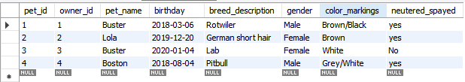

3. classes

INSERT INTO classes (class_code, Class_name, trainer, date, time)

VALUES (1, "Basic Skills", "Shey", 20200306, '02:00:00');

INSERT INTO classes (class_code, Class_name, trainer, date, time)

VALUES (2, "Basic Skills", "Marie", 20200308, '16:00:00');

INSERT INTO classes (class_code, Class_name, trainer, date, time)

VALUES (3, "Walk-Train-Play", "Marie", 20200313, '11:00:00');

INSERT INTO classes (class_code, Class_name, trainer, date, time)

VALUES (4, "Walk-Train-Play", "Trevor", 20200316, '10:00:00');

INSERT INTO classes (class_code, Class_name, trainer, date, time)

VALUES (5, "Off-Leash Opperation", "Rose", 20200324, '10:00:00');

INSERT INTO classes (class_code, Class_name, trainer, date, time)

VALUES (6, "Off-Leash Opperation", "Shey", 20200328, '15:00:00');

Query:

SELECT class_code, Class_name, trainer, date, time

FROM classes

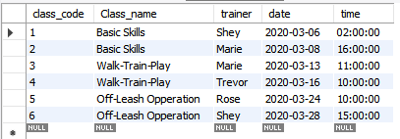

4. trainers

INSERT INTO trainers (trainer_id, trainer_name)

VALUES (20, "Shey");

INSERT INTO trainers (trainer_id, trainer_name)

VALUES (21, "Marie");

INSERT INTO trainers (trainer_id, trainer_name)

VALUES (22, "Trevor");

INSERT INTO trainers (trainer_id, trainer_name)

VALUES (23, "Rose");

Query:

SELECT trainer_id, trainer_name

FROM trainers

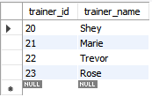

5. pet_training

INSERT INTO pet_training (class_code, pet_id, owner_id, trainer_id, signature)

VALUES (1, 1, 1, 20, "Michael Stowell");

INSERT INTO pet_training (class_code, pet_id, owner_id, trainer_id, signature)

VALUES (3, 2, 2, 21, "Dannie Pothier");

INSERT INTO pet_training (class_code, pet_id, owner_id, trainer_id, signature)

VALUES (5, 3, 3, 23, "Susan Anthony");

INSERT INTO pet_training (class_code, pet_id, owner_id, trainer_id, signature)

VALUES (6, 4, 4, 20, "Tyler Stowell");

Query:

SELECT class_code, pet_id, owner_id, trainer_id, signature

FROM pet_training

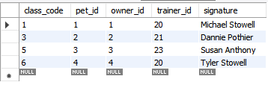

**Other Queries:**

Owner and pet query:

SELECT distinct CONCAT(first_name, ",", last_name, " ", middle_initial) AS owner, pet_name AS "pet", breed_description AS "breed", gender, birthday

FROM owner a, pet b

WHERE a.pet_id = b.pet_id

GROUP BY owner;

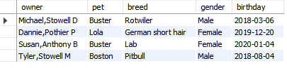

Training events:

SELECT date, time, trainer_name AS "trainer", class_name AS "class", CONCAT(first_name, ",", last_name, " ", middle_initial) AS owner, pet_name AS "pet"

FROM pet_training a, classes b, pet c, trainers d, owner e

WHERE a.class_code = b.class_code and a.pet_id = c.pet_id and a.owner_id = e.owner_id and a.trainer_id = d.trainer_id

